

“Heaven’s Light is Our Guide”

Rajshahi University of Engineering & Technology

**Department of Computer Science & Engineering**

Progress Report

**Course Code :** CSE-2100

**Course Title :**  Software development project I.

|  |  |
| --- | --- |
| **Submitted By**  **Name :** Kafayet Monoar Nahin  **Section :** A  **Roll :** 1903044  **Year :** 2nd Year, Odd Semester  Department of CSE, RUET. | **Submitted To**  **Tasmia Jannat**  Lecturer, Department of CSE, RUET. |

**Progress Report**

**Date:22.06.2022**

* **Learned:**

1. Basic of HTML, CSS(Bootstrap) and Javascript;
2. Learned how to embed a video from youtube;
3. Learned how to create a Navigation Bar.

* **Project Progress:**

1. Developed Navbar using HTML;
2. Developed a static login system and a logout option;
3. Embedded video from youtube for the teaching system;

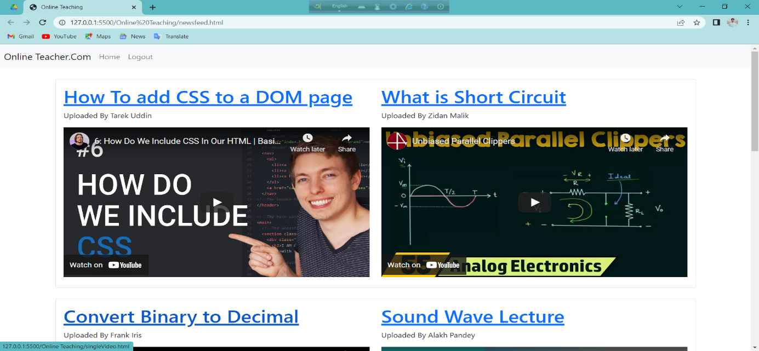

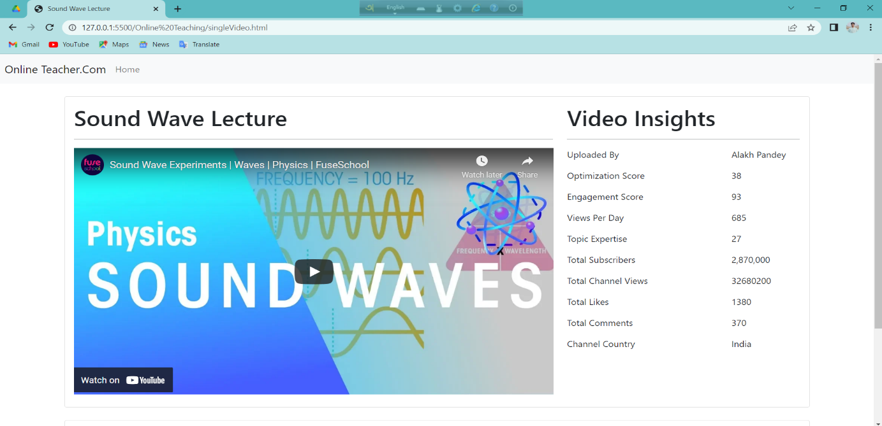

* **Problem:**

No problem right now.

* **Next:**

1. Need to develop signup and dynamic login system;
2. Need to develop the posting system;
3. Including a system for the teachers to take online exams;
4. Need to create a about page.

**Date:30.07.2022**

* **Learned:**

1. Basic of HTML, CSS(Bootstrap) and Javascript;
2. Basic of Django (Python);
3. Learned backend using Django.
4. Learned how to create a dynamic login and registration system.

* **Project Progress:**

1. Developed a dynamic sign up/registration system;
2. Developed a dynamic login system and logout option.

* **Problem:**

No problem right now.

* **Next:**

1. Need to develop the posting system;
2. Including a system for the teachers to take online exams;
3. Need to create a about page.

**Date:23.10.2022**

* **Learned:**

1. Basic of HTML, CSS(Bootstrap) and Javascript;
2. Basic of Django (Python);
3. Learned how to upload a video using Django.

* **Project Progress:**

1. Developed the video uploading or, posting system;
2. Create a page about the website.

* **Problem:**

1. Email verification is not working correctly .